**FAVOURITE SPORTS TEAM:**

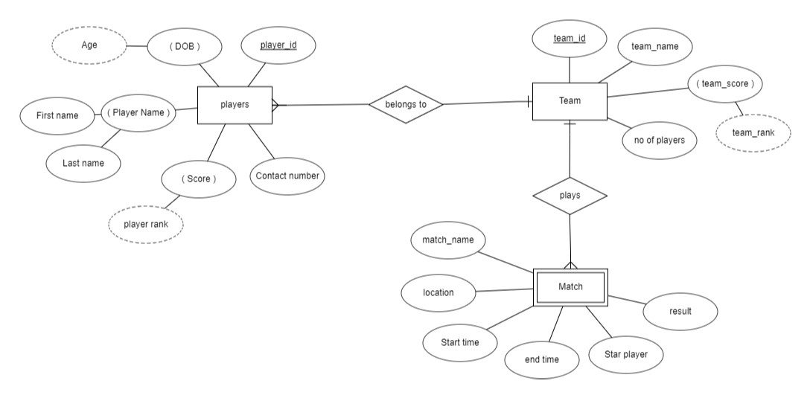

From this ER diagram we can infer that one team consist of many players and the players for a team and plays the match.